**Accessing your mySt.Clair portal in 3 easy steps.**

**STEP 1:** Activate your St. Clair ONE account

In order to access college resources through the **mySt.Clair portal**, you will need to activate your St. Clair ONE account. New students will receive the information needed to activate their St. Clair ONE account in their home email account. Visit <https://www.stclaircollege.ca/it-services> and click on **Activate your St. Clair ONE account.**

**STEP 2:** Log in to the mySt.Clair portal

Visit [www.stclaircollege.ca](http://www.stclaircollege.ca) and click on MYST.CLAIR

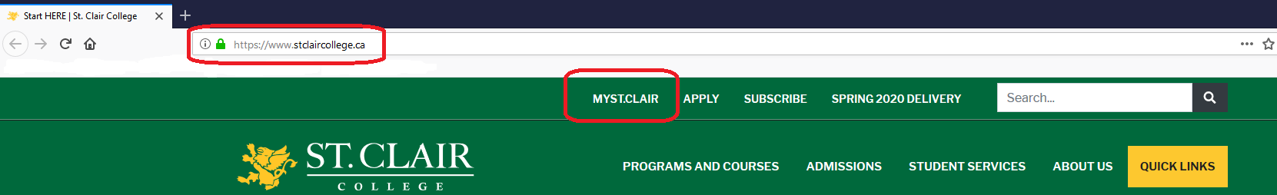

**STEP 3:** Access your college resources (Blackboard, Email, SIS, Teams, etc.)

Once you log in to your mySt.Clair portal, you will see “tiles” with all the college resources available to you.

**What is Microsoft Teams?** Teams is a chat-based tool that provides the ability to chat, meet, call, video call and share information via a common space.

Microsoft Teams is one of the methods to meet with our Student Services staff.

**Off Campus Access**

**How do I start?**

* Go to the St. Clair College website [www.stclaircollege.ca](http://www.stclaircollege.ca) and click on **MYSTCLAIR.** Login with your St. Clair College credentials.

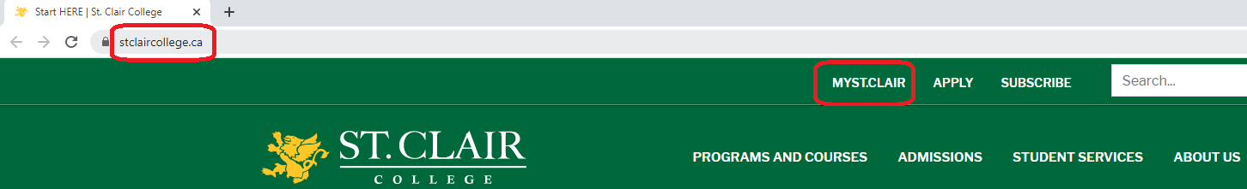

**Accessing Microsoft Teams**

Click on **Office 365 Dashboard** tile on your **Myapps.**

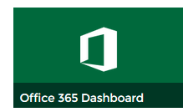

Click on **Microsoft Teams** icon on the left.

You can download the **Microsoft Teams App** or **Use the web app**.

|  |  |
| --- | --- |
|  | **To Download to your computer:** |
| * Click on **Get the Windows app** and follow the prompts to download * You will not need to log into **MYSTCLAIR** to access virtual meetings. Simply click on the installed software (icon) on your computer. |
| **To use the web app:** |
| * Click on the **Use the Web app instead** to use the online version without downloading the software. * You will need to log in with your St. Clair College credentials to access the app. |

**RSVP to email invitation**

You will need to confirm your meeting day/time by doing **one of the following**:

**Email invitation to meeting**

You will get an email invitation to your St. Clair College email (example below). Click **Accept** to accept the invitation. It will then show in your Outlook and Teams calendars.

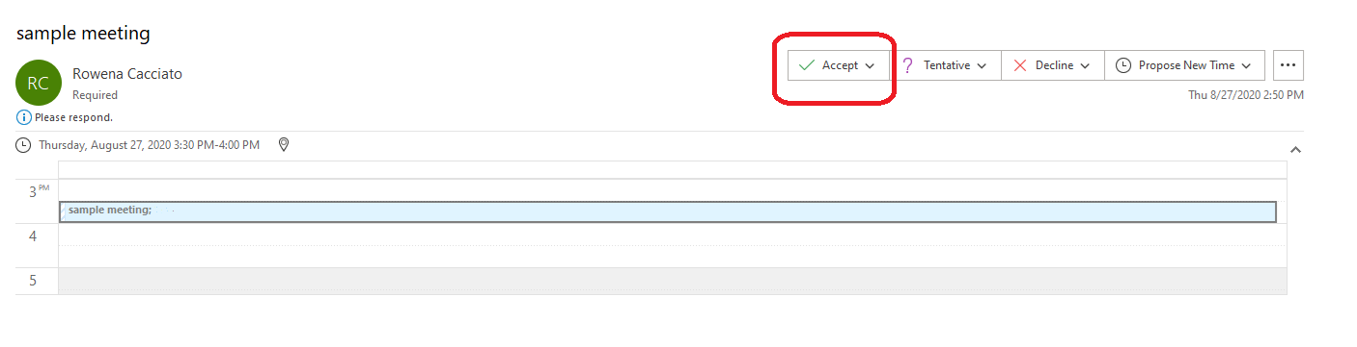

**OR**

**Microsoft Teams Calendar**

You will see an appointment request in your calendar. **You need to double click on the appointment to accept or decline the appointment invitation.**

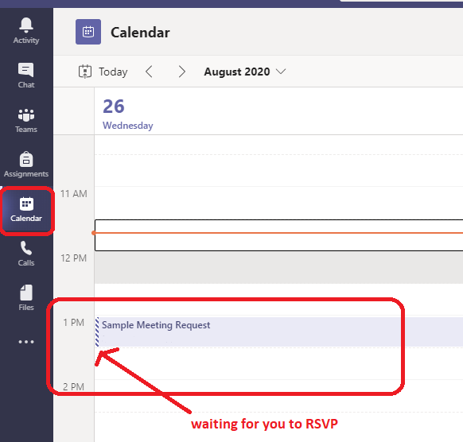

Click on the “down arrow” on the RSVP

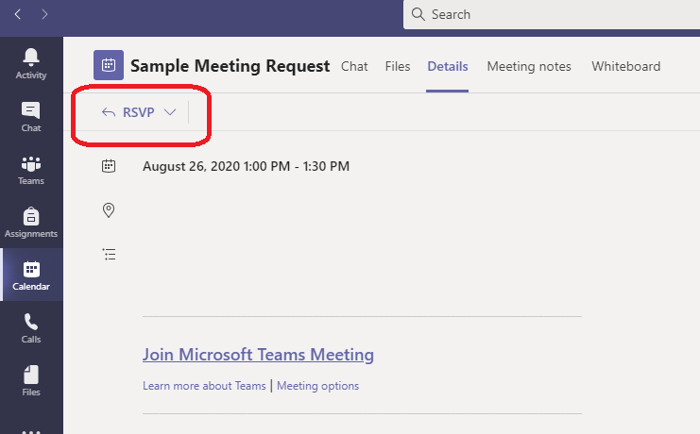

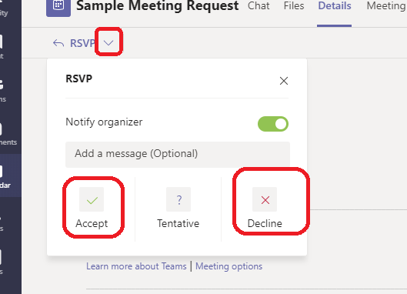

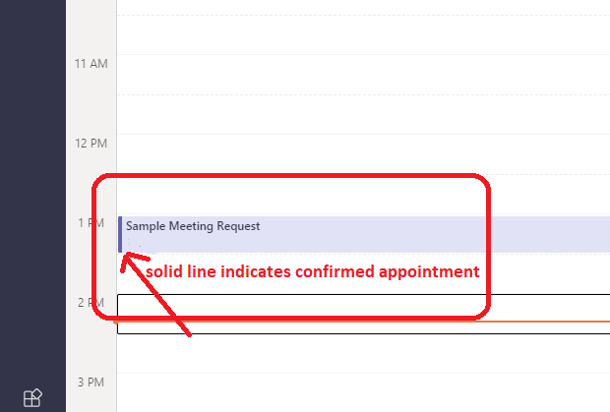

To join the virtual appointment, double click the appointment in your Microsoft Teams calendar at the scheduled date/time and click on **Join** (top right corner).

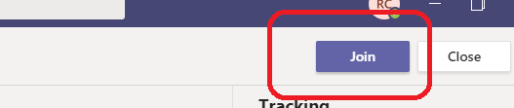

When you are ready, click on **Join now.** You can choose to turn on/off your camera and mute your microphone when needed.

NOTE: you may need to enable/adjust microphone settings on your computer for the audio to work properly

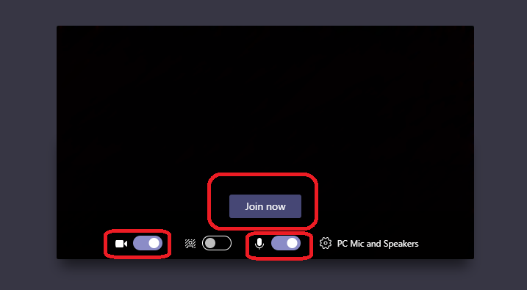

Once you join the session, you will see the following toolbar with several options:

**Turn camera off:**

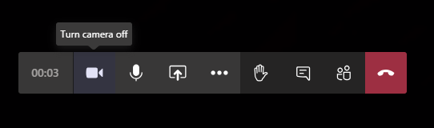

**Mute:**

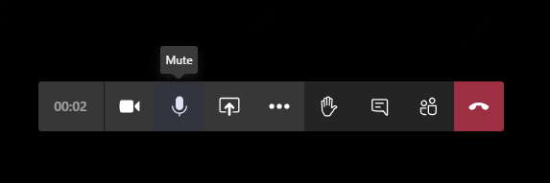

**Share your screen:**

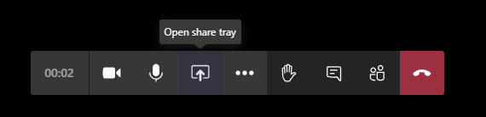

Stop sharing your screen:

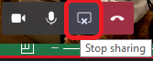

**Options:**

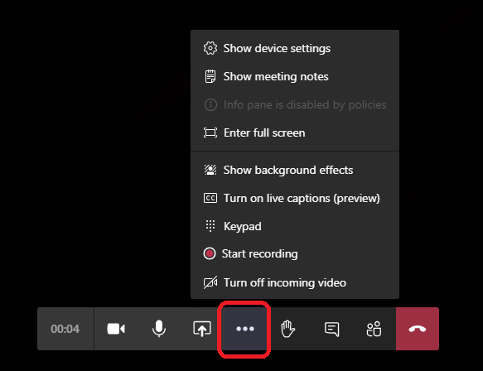

**Raise your hand:**

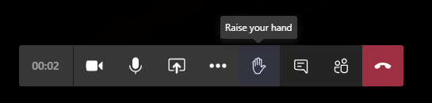

**Show conversation:**

If you are on a meeting with multiple people, you can also type in text/questions in the conversation to the group or to specific people.

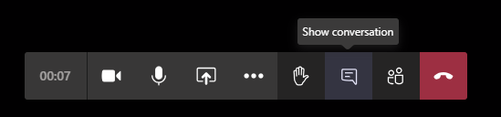

**Show participants:**

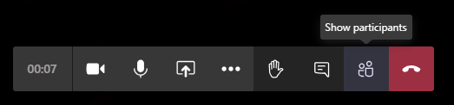

**Hang up:**

